Template for Departmental Activity Report

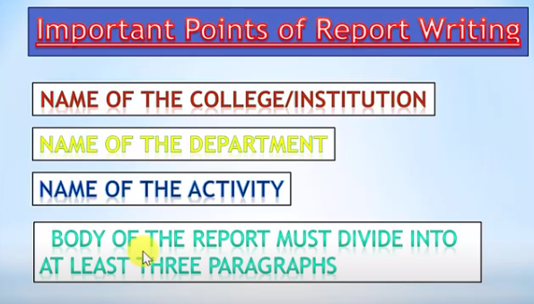
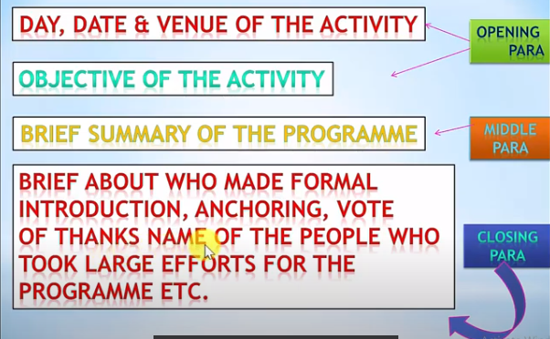
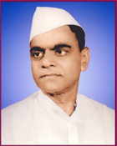
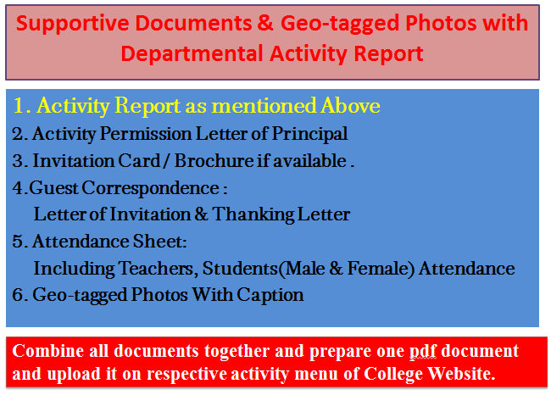
Janata Shikshan Sanstha’s
Kisan Veer Mahavidyalaya,Wai
Department of N. C. C.

SwachtaAbhiyan: Cleaning of Ganpati Ghat, Krishna River, Wai
Report
The department of NCC organized “Swachta Abhiyan : Cleaning of Ganpati Chat, Krishna River,Wai” on 02-10- 2019. The Chief Guest at this time were Hon. Vidhya Pol, CEO, Wai Muncipal Corporation, Wai and Hon. Zanjurne, Forest Officer, Wai . Principal Dr. C.G Yeole welcomed the Chief Guests with a bouquet. Lieutenant Sameer Pawar, welcomed Dr. C. G. Yeole with a bouquet.

Hon. Vidhya Pol appreciated activity of department of NCC. She enlightened about Cleanliness Campaign initiated by Government. In his address, Hon Zanjurne appreciated and pointed out importance of cleanliness. 103 cadets and 100 NSS volunteers participated in the programme.

College Seal
Dr. C. G. Yeole Lieutenant Sameer Pawar
Principal NCC Officer
Kisan Veer Mahavidyalay,Wai NCC Unit
2. Activity Permission Letter of Principal

Paste the PDF

4. 4.Guest Correspondence:
Letter of Invitation & Thanking Letter

Paste the PDF
3. Invitation Card / Brochure if available

Paste the PDF

Combine all documents together and prepare one pdf document and upload it on respective activity menu of College Website.
Caption
Caption
Paste the PDF
Paste the PDF
Caption
Caption
Paste the PDF
Paste the PDF
5. Geo-tagged Photos With Caption

Paste the PDF
5. Attendance Sheet:
Including Teachers, Students
(Male & Female) Attendance

